AIR QUALITY ANALYSIS AND VISUALISATION
A Project Report Submitted in the partial fulfillment of the requirements for the award of the degree of

BACHELOR OF TECHNOLOGY
In

DEPARTMENT OF COMPUTER SCIENCE
By
2420030387 | J.NIKHILA
2420030617 | S.SRINIKA

Under the Esteemed Guidance of
DR.N.SUNANDA
Associate Professor

Department of Computer Science and Engineering

2026-2027

Semester:Odd Semester


K L (Deemed to be) University
DEPARTMENT OF COMPUTER SCIENCE AND ENGINEERING

Declaration

The Project Report entitled “AIR QUALITY ANALYSIS AND VISUALISATION” is a record of Bonafide work of J.Nikhila - 2420030387, S.Srinika - 2420030617 submitted in partial fulfillment for the award of B. Tech in 2026-2027 to the K L University. The results embodied in this report have not been copied from any other departments/University/Institute.

- Nikhila - 2420030387
S.Srinika - 2420030617

K L (Deemed to be) University
DEPARTMENT OF COMPUTER SCIENCE AND ENGINEERING

CERTIFICATE

This is certify that the mini project based report entitled “AIR QUALITY ANALSYIS AND VISUALISATION” is a bonafide work done and submitted by Nikhila-2420030387,S.Srinika- 2420030617 in partial fulfillment of the requirements for the award of the degree of BACHELOR OF TECHNOLOGY in Department of COMPUTER SCIENCE AND ENGINEERING, K L (Deemed to be University), during the academic year 2026-2027.

_____________________  Signature of the Guide  Dr. N. Sunanda  Department of CSE | _____________________  Course Coordinator  Dr. N. Sunanda  Department of CSE | _____________________  Head of the Department  Dr.P. Venkateswara Rao  Department of CSE

ACKNOWLEDGEMENT
The success in this project would not have been possible but for the timely help and guidance rendered by many people. Our wish to express my sincere thanks to all those who has assisted us in one way or the other for the completion of my project.

Our greatest appreciation to my Course Coordinator DR.N.SUNANDA, and my guide DR.N.SUNANDA, Department of CSE which cannot be expressed in words for his/her tremendous support, encouragement and guidance for this project.

We express our gratitude to DR.P.VENKATESHWAR RAO, Head of the Department for CSE for providing us with adequate facilities, ways and means by which we are able to complete this project-based Lab.

We thank all the members of teaching and non-teaching staff members, and also who have assisted me directly or indirectly for successful completion of this project. Finally, I sincerely thank my parents, friends and classmates for their kind help and cooperation during my work.

J.NIKHILA-2420030387
S.SRINIKA-2420030617

ABSTRACT
Air pollution is one of the major environmental concerns affecting human health, environmental quality, and the overall quality of life. The air we breathe contains a mixture of gases and particulate matter, and the concentration of these pollutants can vary from one location to another and over time. Important air-quality parameters include particulate matter such as PM2.5 and PM10, and gaseous pollutants such as nitrogen dioxide (NO₂), sulfur dioxide (SO₂), carbon monoxide (CO), and ozone (O₃). The Air Quality Index (AQI) provides an overall indication of air-quality conditions and helps communicate pollution levels in a form that is easier to understand. However, air-quality datasets often contain a large number of records and multiple variables, making it difficult to identify meaningful patterns by examining raw data alone.
The project entitled “Air Quality Analysis and Visualisation” focuses on applying data-science techniques to organize, analyze, and visually represent air-quality information. The main aim is to convert raw air-quality data into meaningful information that can be interpreted more easily. The proposed process begins with collecting and organizing data containing pollutant measurements and AQI values. The dataset will then be inspected and cleaned by handling missing values and removing unnecessary data. After preparation, basic statistical techniques and Exploratory Data Analysis (EDA) will be used to examine pollution levels, understand variations in measurements, compare air quality across different locations, and study changes in AQI over time.
Python is used as the primary programming language for data analysis and processing. Pandas supports data cleaning, manipulation, and organization, while NumPy is used for numerical calculations. Matplotlib and Seaborn are used to create graphical and statistical visualizations. Jupyter Notebook or Google Colab provides the environment for carrying out the analysis. The planned visual outputs include bar charts for comparisons, line graphs for observing AQI trends over time, histograms for understanding data distributions, box plots for examining variations and possible outliers, and correlation heatmaps for visualizing relationships among pollutant variables.
The expected outcome of the project is a cleaned and organized air-quality dataset accompanied by clear visualizations and meaningful observations. The analysis aims to highlight pollution levels and AQI patterns across different locations, show how AQI changes over time, and provide insights into relationships among the selected pollutants. By presenting complex air-quality information through simple charts and exploratory analysis, the project aims to make the data easier to understand and interpret.

TABLE OF CONTENTS
Abstract
Chapter 1: Introduction
1.1 Background and Motivation
1.2 Problem Statement
1.3 Real-World Relevance
1.4 Objectives
1.5 Scope of the Project
1.6 How the Project Addresses the Gap
Chapter 2: System and Software Requirements
2.1 Data Requirements
2.2 Software Requirements
2.3 Tools and Technologies
Chapter 3: Proposed Methodology and Design
3.1 Overall Workflow
3.2 Data Collection and Organization
3.3 Data Cleaning and Preparation
3.4 Exploratory Data Analysis
3.5 Visualization Techniques
Chapter 4: Analysis Plan and Expected Outputs
4.1 Pollution-Level Analysis
4.2 Location-Wise Comparison
4.3 AQI Trend Analysis
4.4 Pollutant Relationship Analysis
4.5 Expected Outcomes
Chapter 5: Literature Survey
Chapter 6: Conclusion and Future Scope
6.1 Conclusion
6.2 Future Enhancements
References
Appendix A: Project Details

CHAPTER 1
Introduction

1.1 Motivation
Air pollution has become one of the major environmental challenges affecting human health and the quality of life. Rapid urbanisation, industrial activities, increasing numbers of vehicles, construction work, and the burning of fossil fuels contribute significantly to the deterioration of air quality. Exposure to polluted air can lead to various health problems, including respiratory diseases, cardiovascular conditions, and other long-term health complications.
In India, several cities experience different levels of air pollution due to variations in population, traffic, industrial activities, and environmental conditions. Monitoring air quality and understanding the concentration of pollutants are therefore important for identifying pollution patterns and supporting better environmental decisions.
The main motivation behind the project "Air Quality Analysis and Visualisation" is to analyse air pollution data and present meaningful information through graphical representations. By studying pollutants such as PM2.5, PM10, NO₂, SO₂, CO, and O₃, the project aims to understand pollution levels, identify patterns, compare air quality across different cities, and make complex environmental data easier to interpret.

1.2 Objective
The primary objective of "Air Quality Analysis and Visualisation" is to analyse air quality data using data science techniques and represent the findings through meaningful visualisations.
The project focuses on examining the concentration of different air pollutants and understanding their relationship with the Air Quality Index (AQI). It aims to identify pollution trends over time, compare air quality levels across different cities, and determine which pollutants contribute significantly to poor air quality.
The major objectives of the project are:
- To collect and examine air quality data from a suitable dataset.
- To clean and preprocess the dataset by handling missing values and unnecessary information.
- To analyse major air pollutants such as PM2.5, PM10, NO₂, SO₂, CO, and O₃.
- To study AQI variations across different cities and time periods.
- To identify relationships between different pollutants using statistical analysis.
- To create visualisations such as bar charts, line graphs, histograms, box plots, and correlation heatmaps.
- To present the analysed information in a simple and understandable manner.

1.3 What is Data Science?
Data Science is an interdisciplinary field that involves collecting, processing, analysing, and interpreting data to extract useful information and support decision-making. It combines techniques from statistics, mathematics, programming, and domain knowledge to identify patterns, discover relationships, and generate meaningful insights from large datasets.
Data Science involves several stages, including data collection, data cleaning, data preprocessing, exploratory data analysis, visualisation, and interpretation of results. Programming languages such as Python are widely used in data science because they provide powerful libraries for handling and analysing data.
In this project, data science techniques are used to examine air quality information, identify variations in pollutant concentrations, understand AQI patterns, and generate meaningful conclusions from the available dataset.

1.4 What is Air Quality?
Air quality refers to the condition of the air in a particular environment based on the concentration of pollutants present in it. Clean air contains pollutants at relatively low concentrations, whereas poor air quality occurs when harmful substances are present at levels that may affect human health and the environment.
Common air pollutants include particulate matter (PM2.5 and PM10), nitrogen dioxide (NO₂), sulphur dioxide (SO₂), carbon monoxide (CO), and ozone (O₃). These pollutants can originate from sources such as vehicle emissions, industrial processes, construction activities, fuel combustion, and other human activities.
The Air Quality Index (AQI) is used to communicate the overall quality of air through a numerical value and corresponding categories. It helps people understand whether the air quality is satisfactory or whether pollution levels may create health concerns.
In this project, air quality data is analysed to understand the concentration of different pollutants and examine variations in AQI across different cities and time periods.

1.5 What is Data Visualisation?
Data Visualisation is the process of representing information and data through graphical formats such as charts, graphs, and plots. It helps transform complex datasets into visual representations that are easier to understand, interpret, and analyse.
Visualisation plays an important role in data science because it allows users to identify patterns, trends, distributions, and relationships that may not be easily noticeable in raw numerical data.
Different types of visualisations are used depending on the purpose of the analysis. Bar charts help compare values across different categories, line graphs represent changes over time, histograms show the distribution of numerical data, box plots identify the spread of data and possible outliers, and correlation heatmaps illustrate relationships between numerical variables.
In the "Air Quality Analysis and Visualisation" project, data visualisation techniques are used to represent pollutant concentrations, compare air quality among cities, study AQI trends, and understand the relationships between different air pollutants. Python libraries such as Matplotlib and Seaborn are used to create these graphical representations.

CHAPTER 2
SOFTWARE REQUIREMENTS

2.1 Problem Statement
Air pollution is one of the major environmental concerns affecting human health and the environment. Increasing vehicle emissions, industrial activities, construction, and urbanisation contribute to the rising concentration of harmful pollutants in the atmosphere. Understanding air pollution levels is essential for identifying environmental problems and creating awareness about air quality.
However, analysing large amounts of air quality data manually can be difficult and time-consuming. Raw datasets contain numerical values, missing observations, and information that may not be easily understood without proper analysis and visualisation. Therefore, there is a need for an efficient approach to process, analyse, and interpret air quality data.
The main problem addressed by the project "Air Quality Analysis and Visualisation" is the difficulty in understanding air pollution patterns and identifying relationships between different pollutants. The project uses data science techniques to analyse pollutants such as PM2.5, PM10, NO₂, SO₂, CO, and O₃, along with the Air Quality Index (AQI).
The project aims to clean and process the available dataset, perform exploratory data analysis, compare pollution levels across different cities, and identify variations in air quality over time. Different graphical representations are used to present the findings in a simple and understandable manner.

2.2 Technologies Used

1. Python
Python is a high-level, interpreted, and general-purpose programming language widely used in data science, machine learning, and data analysis. It provides a simple syntax and a large collection of libraries that make it suitable for processing and analysing large datasets.
Python supports various operations such as data manipulation, statistical calculations, data cleaning, and visualisation. In this project, Python is used as the primary programming language to process air quality data, perform calculations, analyse pollutant concentrations, and generate visualisations.
General Syntax of Python:
# Display a message
print("Air Quality Analysis and Visualisation")

# Create variables
pm25 = 45
pm10 = 80

# Calculate average
average = (pm25 + pm10) / 2

print("Average:", average)

2. Pandas
Pandas is an open-source Python library used for data manipulation and analysis. It provides powerful data structures such as Series and DataFrame, which make it easier to work with structured data.
Pandas is commonly used to read datasets, handle missing values, filter records, remove unnecessary columns, and perform data operations. It supports file formats such as CSV and Excel.
In this project, Pandas is used to load the air quality dataset, inspect its structure, handle missing values, clean the data, and organise pollutant information for further analysis.
General Syntax of Pandas:
import pandas as pd

# Load dataset
data = pd.read_csv("city_day.csv")

# Display first five records
print(data.head())

# Display dataset information
print(data.info())

# Check missing values
print(data.isnull().sum())

3. NumPy
NumPy (Numerical Python) is a Python library used for numerical computing and mathematical operations. It provides support for multidimensional arrays, matrices, and a wide range of mathematical functions.
NumPy makes numerical calculations faster and more efficient. It is widely used in data science for statistical calculations, array operations, and mathematical analysis.
In this project, NumPy is used to perform numerical operations and support statistical calculations related to air pollutant concentrations and AQI values.
General Syntax of NumPy:
import numpy as np

# Create an array
pollutants = np.array([25, 40, 55, 60, 70])

# Calculate average
average = np.mean(pollutants)

# Calculate maximum value
maximum = np.max(pollutants)

print("Average:", average)
print("Maximum:", maximum)

4. Matplotlib
Matplotlib is a widely used Python library for creating static, animated, and interactive visualisations. It provides functions to generate different types of charts and graphs, including line graphs, bar charts, histograms, and scatter plots.
Matplotlib helps represent numerical information in a graphical format, making it easier to understand trends and comparisons.
In this project, Matplotlib is used to visualise air quality information, compare pollutant concentrations, and study changes in AQI over time.
General Syntax of Matplotlib:
import matplotlib.pyplot as plt

cities = ["Delhi", "Mumbai", "Chennai", "Kolkata"]
aqi = [250, 120, 80, 150]

plt.bar(cities, aqi)
plt.xlabel("Cities")
plt.ylabel("AQI")
plt.title("Air Quality Comparison")
plt.show()

5. Seaborn
Seaborn is a Python data visualisation library built on top of Matplotlib. It provides a high-level interface for creating attractive and informative statistical graphics.
Seaborn supports visualisations such as heatmaps, box plots, distribution plots, and scatter plots. It is particularly useful for understanding relationships and patterns within datasets.
In this project, Seaborn is used to create correlation heatmaps and box plots to analyse relationships between pollutants, understand data distributions, and identify possible outliers.
General Syntax of Seaborn:
import seaborn as sns
import matplotlib.pyplot as plt
import pandas as pd

data = pd.DataFrame({
"PM2.5": [25, 40, 55, 60],
"PM10": [50, 65, 80, 90],
"AQI": [60, 100, 130, 150]
})

sns.heatmap(data.corr(), annot=True, cmap="coolwarm")
plt.title("Correlation Heatmap")
plt.show()

2.3 Software Used

2.3.1 Google Colab / Jupyter Notebook
Google Colab is a cloud-based platform that allows users to write and execute Python code through a web browser. It provides a notebook-based environment where code, text, visualisations, and outputs can be organised together.
Jupyter Notebook is an open-source web application used for interactive computing. It allows users to create and execute Python code in separate cells and display the results immediately.
Both platforms are widely used for data science projects because they support Python libraries such as Pandas, NumPy, Matplotlib, and Seaborn.
In this project, Google Colab or Jupyter Notebook is used as the development environment to execute Python programs, load the air quality dataset, perform data preprocessing, conduct exploratory data analysis, and generate graphical visualisations.
Main Features:
- Provides an interactive Python programming environment.
- Supports execution of code in individual cells.
- Allows easy integration of data analysis libraries.
- Displays graphs and visualisations directly within the notebook.
- Supports uploading and analysing CSV datasets.
- Helps organise code, explanations, and results in a single document.

CHAPTER 3
Software Design

3.1 DFD
A data-flow diagram (DFD) is a way of representing a flow of a data of a process or a system (usually an information system). The DFD also provides information about the outputs and inputs of each entity and the process itself. A data-flow diagram has no control flow, there are no decision rules and no loops. Specific operations based on the data can be represented by a flowchart.

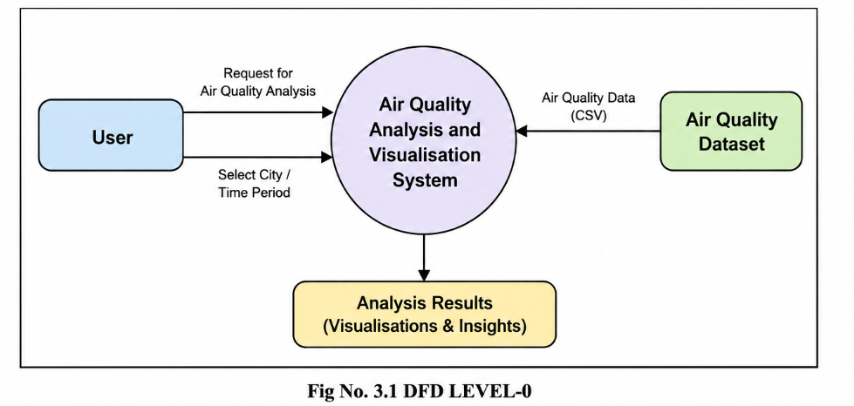

CHAPTER 4
Implementation and User Interface

4.1 Pollution-Level Analysis
The project will examine the available measurements for PM2.5, PM10, NO₂, SO₂, CO, O₃, and AQI. Basic statistical summaries and suitable charts will be used to understand the levels and variation of these parameters. Specific numerical findings will be reported only after the selected dataset has been processed.

4.2 Location-Wise Comparison
Air-quality levels will be compared across the locations represented in the dataset. This comparison is intended to identify differences in pollutant levels and AQI between locations. The final locations included in the comparison will depend on the coverage of the selected dataset.

4.3 AQI Trend Analysis
Time-based records will be used to study changes in AQI over the available period. A line graph can present increases, decreases, and variations in AQI, helping the reader understand how air-quality conditions change over time.

4.4 Pollutant Relationship Analysis
Relationships among pollutant variables will be explored using statistical visualization, including a correlation heatmap. This can help identify variables that show stronger or weaker associations in the dataset. Such associations will be interpreted as relationships in the data and not automatically as proof of cause and effect.

4.5 Expected Outcomes
- A cleaned and organized air-quality dataset ready for analysis.
- Identification of pollution levels and AQI patterns for different locations.
- Analysis of changes in AQI over time.
- Comparison of air-quality levels across different locations.
- Identification of relationships between different pollutants.
- Clear visualizations using bar charts, line graphs, histograms, box plots, and correlation heatmaps.
- Meaningful insights from raw air-quality data using Python and data-science techniques.
These are expected outcomes stated in the project review presentation. They are not presented here as completed experimental results.

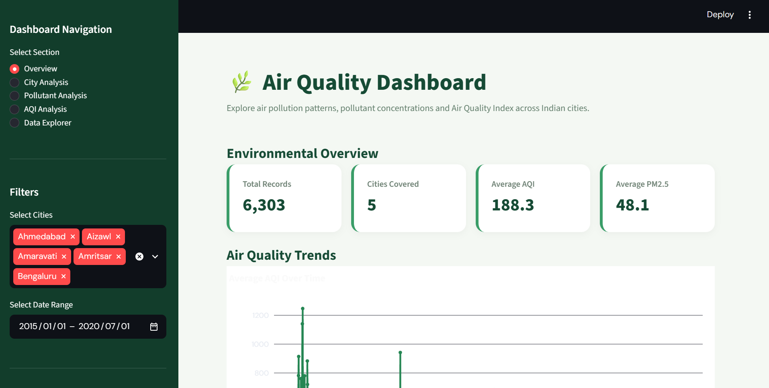

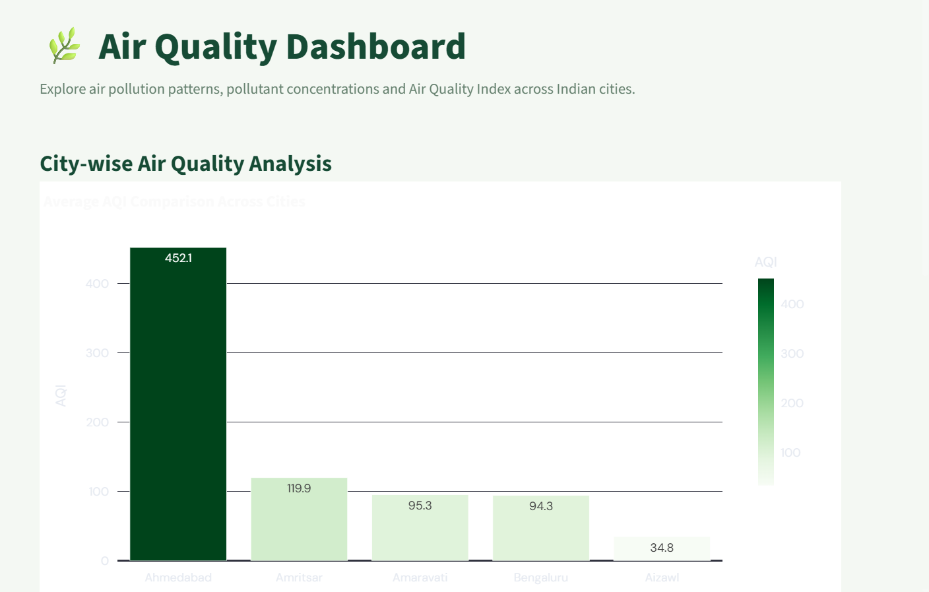

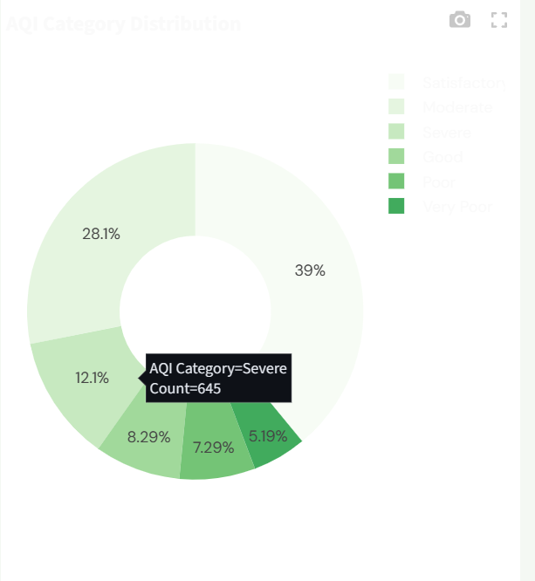

CHAPTER 5

Conclusion and Future Aspects

5.1 Conclusion
The project "Air Quality Analysis and Visualisation" focuses on analysing air pollution data using Python and its libraries. It helps examine pollutant concentrations, study AQI variations, and identify relationships between different pollutants. Visualisations such as bar charts, line graphs, and heatmaps make the data easier to understand.

5.2 Future Aspects
- Real-time air quality monitoring can be introduced.
- Machine learning can be used to predict future AQI values.
- An interactive dashboard can be developed.
- More cities can be included for comparison.
- Alerts can be provided when pollution levels are high.

CHAPTER 6
Bibliography

- https://www.python.org/
- https://pandas.pydata.org/docs/
- https://numpy.org/doc/
- https://matplotlib.org/stable/
- https://seaborn.pydata.org/
- https://www.kaggle.com/datasets/rohanrao/air-quality-data-in-india
- https://colab.research.google.com/

CHAPTER 7

Appendices

1.import streamlit as st
import pandas as pd
import numpy as np
import plotly.express as px
import plotly.graph_objects as go
from pathlib import Path

# --------------------------------------------------
# PAGE CONFIGURATION
# --------------------------------------------------

st.set_page_config(
page_title="Air Quality Analysis Dashboard",
page_icon="🌿",
layout="wide",
initial_sidebar_state="expanded"
)

# --------------------------------------------------
# CUSTOM CSS
# --------------------------------------------------

st.markdown("""
<style>

@import url('https://fonts.googleapis.com/css2?family=DM+Sans:wght@400;500;600;700;800&display=swap');

html, body, [class*="css"] {
font-family: 'DM Sans', sans-serif;
}

.stApp {
background-color: #F4F8F3;
}

[data-testid="stSidebar"] {
background-color: #123D2B;
}

[data-testid="stSidebar"] * {
color: white !important;
}

.main-title {
font-size: 38px;
font-weight: 800;
color: #164B35;
margin-bottom: 0;
}

.subtitle {
color: #66816F;
font-size: 15px;
margin-bottom: 25px;
}

.metric-card {
background: white;
padding: 22px;
border-radius: 15px;
border-left: 5px solid #3A9D68;
box-shadow: 0 3px 12px rgba(0,0,0,0.04);
}

.metric-label {
color: #718477;
font-size: 14px;
font-weight: 600;
}

.metric-value {
color: #164B35;
font-size: 29px;
font-weight: 800;
}

.section-title {
color: #164B35;
font-size: 23px;
font-weight: 700;
margin-top: 20px;
}

.info-card {
background: #E5F2E8;
padding: 18px;
border-radius: 12px;
color: #164B35;
}

</style>
""", unsafe_allow_html=True)

# --------------------------------------------------
# LOAD DATASET
# --------------------------------------------------

@st.cache_data
def load_data():

possible_paths = [
Path("data/city_day.csv"),
Path("city_day.csv")
]

file_path = None

for path in possible_paths:
if path.exists():
file_path = path
break

if file_path is None:
return None

df = pd.read_csv(file_path)

df.columns = df.columns.str.strip()

if "Date" in df.columns:
df["Date"] = pd.to_datetime(
df["Date"],
errors="coerce"
)

numeric_columns = df.select_dtypes(
include=["number"]
).columns

for column in numeric_columns:
df[column] = pd.to_numeric(
df[column],
errors="coerce"
)

return df

df = load_data()

# --------------------------------------------------
# CHECK DATASET
# --------------------------------------------------

if df is None:

st.error(
"Dataset not found. Please place city_day.csv "
"inside the data folder."
)

st.stop()

if "City" not in df.columns:

st.error("The dataset does not contain a City column.")

st.stop()

if "Date" not in df.columns:

st.error("The dataset does not contain a Date column.")

st.stop()

# --------------------------------------------------
# SIDEBAR
# --------------------------------------------------

st.sidebar.markdown("## 🌿 AIR QUALITY")
st.sidebar.markdown("### Analysis Dashboard")

st.sidebar.markdown("---")

st.sidebar.markdown("### Dashboard Navigation")

page = st.sidebar.radio(
"Select Section",
[
"Overview",
"City Analysis",
"Pollutant Analysis",
"AQI Analysis",
"Data Explorer"
]
)

st.sidebar.markdown("---")

st.sidebar.markdown("### Filters")

cities = sorted(
df["City"].dropna().unique().tolist()
)

selected_cities = st.sidebar.multiselect(
"Select Cities",
cities,
default=cities[:min(5, len(cities))]
)

if not selected_cities:
selected_cities = cities

filtered_df = df[
df["City"].isin(selected_cities)
].copy()

if not filtered_df.empty:

min_date = filtered_df["Date"].min().date()
max_date = filtered_df["Date"].max().date()

date_range = st.sidebar.date_input(
"Select Date Range",
value=(min_date, max_date),
min_value=min_date,
max_value=max_date
)

if isinstance(date_range, tuple) and len(date_range) == 2:

start_date, end_date = date_range

filtered_df = filtered_df[
(filtered_df["Date"].dt.date >= start_date) &
(filtered_df["Date"].dt.date <= end_date)
]

st.sidebar.markdown("---")

st.sidebar.caption(
"Air Quality Analysis and Visualisation | 2026–2027"
)

# --------------------------------------------------
# COMMON FUNCTIONS
# --------------------------------------------------

pollutants = [
"PM2.5",
"PM10",
"NO",
"NO2",
"NOx",
"NH3",
"CO",
"SO2",
"O3"
]

available_pollutants = [
col for col in pollutants
if col in filtered_df.columns
]

def metric_card(label, value):

st.markdown(
f"""
<div class="metric-card">
<div class="metric-label">{label}</div>
<div class="metric-value">{value}</div>
</div>
""",
unsafe_allow_html=True
)

def section_heading(title):

st.markdown(
f'<div class="section-title">{title}</div>',
unsafe_allow_html=True
)

def green_chart(fig):

fig.update_layout(
template="plotly_white",
font=dict(
family="DM Sans",
color="#164B35"
),
margin=dict(
l=20,
r=20,
t=50,
b=20
),
paper_bgcolor="white",
plot_bgcolor="white"
)

st.plotly_chart(
fig,
use_container_width=True
)

# --------------------------------------------------
# HEADER
# --------------------------------------------------

st.markdown(
'<div class="main-title">🌿 Air Quality Dashboard</div>',
unsafe_allow_html=True
)

st.markdown(
'<div class="subtitle">'
'Explore air pollution patterns, pollutant concentrations '
'and Air Quality Index across Indian cities.'
'</div>',
unsafe_allow_html=True
)

# --------------------------------------------------
# OVERVIEW PAGE
# --------------------------------------------------

if page == "Overview":

section_heading("Environmental Overview")

if filtered_df.empty:
st.warning("No data available for the selected filters.")
st.stop()

total_records = len(filtered_df)

total_cities = filtered_df["City"].nunique()

avg_aqi = (
filtered_df["AQI"].mean()
if "AQI" in filtered_df.columns
else np.nan
)

avg_pm25 = (
filtered_df["PM2.5"].mean()
if "PM2.5" in filtered_df.columns
else np.nan
)

col1, col2, col3, col4 = st.columns(4)

with col1:
metric_card(
"Total Records",
f"{total_records:,}"
)

with col2:
metric_card(
"Cities Covered",
f"{total_cities}"
)

with col3:
metric_card(
"Average AQI",
f"{avg_aqi:.1f}" if pd.notna(avg_aqi) else "N/A"
)

with col4:
metric_card(
"Average PM2.5",
f"{avg_pm25:.1f}" if pd.notna(avg_pm25) else "N/A"
)

section_heading("Air Quality Trends")

if "AQI" in filtered_df.columns:

trend_data = (
filtered_df
.dropna(subset=["Date", "AQI"])
.groupby("Date")["AQI"]
.mean()
.reset_index()
)

fig = px.line(
trend_data,
x="Date",
y="AQI",
title="Average AQI Over Time",
markers=True
)

fig.update_traces(
line=dict(color="#258653", width=3)
)

green_chart(fig)

col1, col2 = st.columns(2)

with col1:

if "City" in filtered_df.columns and "AQI" in filtered_df.columns:

city_aqi = (
filtered_df
.groupby("City")["AQI"]
.mean()
.reset_index()
.sort_values("AQI", ascending=False)
)

fig = px.bar(
city_aqi,
x="City",
y="AQI",
title="Average AQI by City",
color="AQI",
color_continuous_scale="Greens"
)

green_chart(fig)

with col2:

if "AQI_Bucket" in filtered_df.columns:

bucket_data = (
filtered_df["AQI_Bucket"]
.value_counts()
.reset_index()
)

bucket_data.columns = [
"AQI Category",
"Count"
]

fig = px.pie(
bucket_data,
names="AQI Category",
values="Count",
title="AQI Category Distribution",
hole=0.45,
color_discrete_sequence=px.colors.sequential.Greens
)

green_chart(fig)

# --------------------------------------------------
# CITY ANALYSIS
# --------------------------------------------------

elif page == "City Analysis":

section_heading("City-wise Air Quality Analysis")

if filtered_df.empty:
st.warning("No data available for the selected filters.")
st.stop()

if "AQI" in filtered_df.columns:

city_data = (
filtered_df
.groupby("City")["AQI"]
.mean()
.reset_index()
.sort_values("AQI", ascending=False)
)

fig = px.bar(
city_data,
x="City",
y="AQI",
color="AQI",
title="Average AQI Comparison Across Cities",
color_continuous_scale="Greens",
text_auto=".1f"
)

green_chart(fig)

section_heading("City AQI Statistics")

st.dataframe(
city_data,
use_container_width=True,
hide_index=True
)

else:

st.warning("AQI column is not available in the dataset.")

# --------------------------------------------------
# POLLUTANT ANALYSIS
# --------------------------------------------------

elif page == "Pollutant Analysis":

section_heading("Pollutant Concentration Analysis")

if filtered_df.empty:
st.warning("No data available for the selected filters.")
st.stop()

if not available_pollutants:

st.warning("No pollutant columns found.")

else:

selected_pollutant = st.selectbox(
"Choose Pollutant",
available_pollutants
)

pollutant_data = filtered_df[
["Date", "City", selected_pollutant]
].dropna()

avg_value = pollutant_data[
selected_pollutant
].mean()

max_value = pollutant_data[
selected_pollutant
].max()

col1, col2 = st.columns(2)

with col1:
metric_card(
"Average Concentration",
f"{avg_value:.2f}"
)

with col2:
metric_card(
"Maximum Concentration",
f"{max_value:.2f}"
)

daily_data = (
pollutant_data
.groupby("Date")[selected_pollutant]
.mean()
.reset_index()
)

fig = px.line(
daily_data,
x="Date",
y=selected_pollutant,
title=f"{selected_pollutant} Concentration Over Time",
markers=True
)

fig.update_traces(
line=dict(color="#258653", width=3)
)

green_chart(fig)

city_pollutant = (
pollutant_data
.groupby("City")[selected_pollutant]
.mean()
.reset_index()
.sort_values(
selected_pollutant,
ascending=False
)
)

fig = px.bar(
city_pollutant,
x="City",
y=selected_pollutant,
title=f"Average {selected_pollutant} by City",
color=selected_pollutant,
color_continuous_scale="Greens"
)

green_chart(fig)

# --------------------------------------------------
# AQI ANALYSIS
# --------------------------------------------------

elif page == "AQI Analysis":

section_heading("Air Quality Index Analysis")

if filtered_df.empty:
st.warning("No data available for the selected filters.")
st.stop()

if "AQI" not in filtered_df.columns:

st.warning("AQI column is unavailable.")

else:

aqi_data = filtered_df.dropna(
subset=["AQI"]
)

col1, col2, col3 = st.columns(3)

with col1:
metric_card(
"Average AQI",
f"{aqi_data['AQI'].mean():.2f}"
)

with col2:
metric_card(
"Maximum AQI",
f"{aqi_data['AQI'].max():.2f}"
)

with col3:
metric_card(
"Minimum AQI",
f"{aqi_data['AQI'].min():.2f}"
)

fig = px.histogram(
aqi_data,
x="AQI",
nbins=30,
title="Distribution of Air Quality Index",
color_discrete_sequence=["#3A9D68"]
)

green_chart(fig)

if "AQI_Bucket" in aqi_data.columns:

bucket_data = (
aqi_data["AQI_Bucket"]
.value_counts()
.reset_index()
)

bucket_data.columns = [
"AQI Category",
"Number of Records"
]

fig = px.bar(
bucket_data,
x="AQI Category",
y="Number of Records",
title="Air Quality Category Distribution",
color="AQI Category",
color_discrete_sequence=px.colors.sequential.Greens
)

green_chart(fig)

section_heading("AQI by City")

city_aqi = (
aqi_data
.groupby("City")["AQI"]
.mean()
.reset_index()
.sort_values("AQI", ascending=False)
)

fig = px.bar(
city_aqi,
x="City",
y="AQI",
title="Average AQI Across Selected Cities",
color="AQI",
color_continuous_scale="Greens"
)

green_chart(fig)

# --------------------------------------------------
# DATA EXPLORER
# --------------------------------------------------

elif page == "Data Explorer":

section_heading("Dataset Explorer")

st.markdown(
'<div class="info-card">'
'Explore the selected air quality records and '
'understand the structure of the dataset.'
'</div>',
unsafe_allow_html=True
)

if filtered_df.empty:
st.warning("No data available for the selected filters.")
st.stop()

col1, col2 = st.columns(2)

with col1:
metric_card(
"Rows",
f"{filtered_df.shape[0]:,}"
)

with col2:
metric_card(
"Columns",
f"{filtered_df.shape[1]}"
)

section_heading("Dataset Preview")

st.dataframe(
filtered_df,
use_container_width=True,
height=400
)

section_heading("Missing Values")

missing = (
filtered_df.isnull()
.sum()
.reset_index()
)

missing.columns = [
"Column",
"Missing Values"
]

fig = px.bar(
missing,
x="Column",
y="Missing Values",
title="Missing Values in Dataset",
color="Missing Values",
color_continuous_scale="Greens"
)

green_chart(fig)

section_heading("Descriptive Statistics")

st.dataframe(
filtered_df.describe(
include="all"
),
use_container_width=True
)

# --------------------------------------------------
# FOOTER
# --------------------------------------------------

st.markdown("---")

st.markdown(
"""
<div style="text-align:center; color:#66816F; padding:15px;">
🌿 <b>Air Quality Analysis and Visualisation</b><br>
Data Science Project | 2026–2027<br>
Built using Python, Pandas, Plotly and Streamlit
</div>
""",
unsafe_allow_html=True
)
7.2 ANALYSIS.PY
import pandas as pd
import numpy as np

POLLUTANTS = ["PM2.5", "PM10", "NO2", "SO2", "CO", "O3"]

def load_data(file):
df = pd.read_csv(file)

required_columns = ["City", "Date", "AQI"]

for col in required_columns:
if col not in df.columns:
raise ValueError(f"Required column missing: {col}")

return df

def clean_data(df):
data = df.copy()

data["Date"] = pd.to_datetime(
data["Date"], errors="coerce"
)

data["AQI"] = pd.to_numeric(
data["AQI"], errors="coerce"
)

for col in POLLUTANTS:
if col in data.columns:
data[col] = pd.to_numeric(
data[col], errors="coerce"
)

data.drop_duplicates(inplace=True)

data.dropna(
subset=["City", "Date"],
inplace=True
)

for col in POLLUTANTS:
if col in data.columns:
if data[col].notna().any():
data[col] = data[col].fillna(
data[col].median()
)

data["AQI_Category"] = data["AQI"].apply(
classify_aqi
)

return data

def classify_aqi(value):

if pd.isna(value):
return "Unknown"

if value <= 50:
return "Good"

elif value <= 100:
return "Satisfactory"

elif value <= 200:
return "Moderate"

elif value <= 300:
return "Poor"

elif value <= 400:
return "Very Poor"

else:
return "Severe"

def get_pollutants(df):

return [
col for col in POLLUTANTS
if col in df.columns
]

